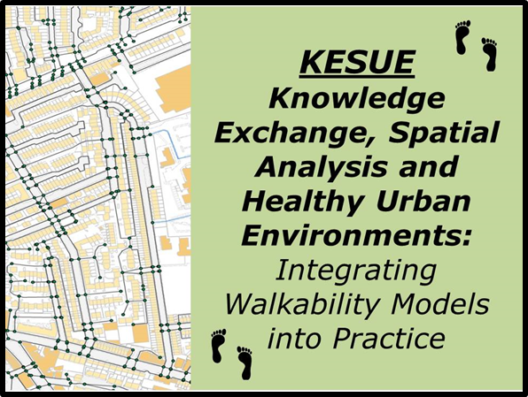
Walkability Workshop
10.00-1.00
Thursday 21st March
Glasgow Centre for Population Health

Places are free, but please register in advance with Russell Jones.
Tel: 0141 287 6741
e-mail: russell.jones@drs.glasgow.gov.uk

Knowledge Exc

This half-day workshop will present the findings of a year-long project, Knowledge Exchange, Spatial Analysis and Healthy Urban Environments (KESUE). This has explored a range of tools that can be used to map and analyse accessibility or walkability with the aim of supporting a stronger evidence base for Healthy Urban Planning.
The purposes of the workshop are to:
- Explore the role of the built environment in influencing physical activity and health;
- Discuss how to measure and assess the walkability and accessibility of the built environment;
- Describe the activities under the KESUE project and highlight a range of case studies in how it has been used;
- Explore potential applications of these tools in promoting active travel in Glasgow.
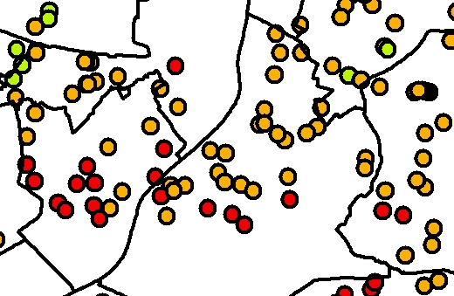
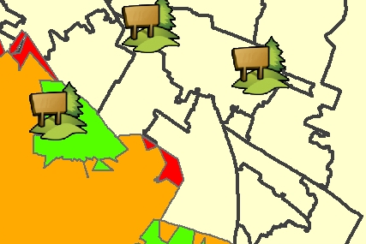
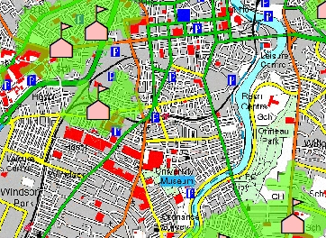
KESUE is being undertaken by the School of Planning, Architecture and Civil Engineering and the Centre for Excellence in Public Health at Queen’s University Belfast, in conjunction with a range of partners that includes the Economic and Social Research Council (ESRC), Dept. of Regional Development, Belfast City Council, Derry City Council, the Public Health Agency and Belfast Healthy Cities.

For more information see: http://www.qub.ac.uk/research-centres/KnowledgeExchangeSpatialAnalysisandHealthyUrbanEnvironments/


Walkability Workshop
Glasgow Centre for Population Health
House 6, 1st Floor
94 Elmbank Street
Glasgow G2 4DL

Thursday 21st March 2013

Outline Programme
1000: | Introductions and purposes of the workshop
1005: | Background to the KESUE project
1020: | Understanding walkability, physical activity and built environment interventions  Questions and discussion
1050: | Developing the Real Walkable Network (RWN)  Questions and discussion
1110 | Break
1130: | Walkability analysis using the RWN: Case Studies and Applications  Questions and discussion
1200 | Discussion:  What are the lessons, priorities and potential applications for Glasgow?
1300 | Close

The project will be led by Professor Geraint Ellis, of the School of Planning, Architecture and Civil Engineering at Queen’s University Belfast.
(see: http://pure.qub.ac.uk/portal/en/persons/geraint-ellis(baeda811-7a40-4a2c-b18f-531c31a07cd7).html )

